Games, Literacy, and Empowerment: An Examination of Game of Floods as a Risk Communication Artifact

Madison E. Perry

Old Dominion University

Abstract

This paper explores the potential of games to serve as a vehicle for risk communication and the transmission of knowledge with respect to climate change messages. Through user experience (UX) testing and observation of participants playing the Game of Floods, students in English 231C examined the effectiveness of Game of Floods as a communicative artifact. Student researchers endeavored to assess how players interact with Game of Floods and which aspects allowed it to effectively impart information on the topics of coastal flooding and associated adaptation strategies. This study included brief pre- and post-gameplay surveys administered to volunteer game participants, who were solicited voluntarily from Old Dominion University. Student researchers used grounded theory and inductive thematic analysis to draw conclusions from the data.

**Introduction**

The term “climate change”, adopted as a broader replacement to “global warming” succeeds in being both accurate and diplomatic, yet perhaps fails to make understood the direct threats to human life and livelihood posed as a result of trapped carbon emissions. As the Earth warms, thermal expansion causes sea levels to rise, while the melting of land-based ice exacerbates this phenomenon (NOAA, 2018).

Approximately 40% of the world’s population lives in high-density coastal areas, and therefore when these areas are threatened by rising seas and more frequent extreme weather devastation, the subsequent damage radiates (NOAA, 2018). From the inundation of homes and erasure of historical sites, to disruptions in the supply chain, climate change and the resultant sea level rise affect every human on Earth, regardless of proximity to the ocean. Not only are the sea levels rising, but they are rising at an increasing rate (NOAA, 2018), so as time goes on, the urgency of this threat grows exponentially. While the latest assessment released by the U.N. Intergovernmental Panel on Climate Change (IPCC, 2018) states that there are approximately 12 years remaining before the Earth’s climate surpasses the scientifically-deemed maximum acceptable amount of warming, coastal communities are already experiencing more frequent severe weather, more damaging king tides, and property/infrastructure devastation due to flooding.

Given the immense urgency of climate-related threats, widespread understanding and productive discussion are essential. In order to encourage widespread understanding and fruitful discussion about mitigation and adaptation to rising sea levels, groups like the Federal Emergency Management Agency (FEMA) and the Urban Sustainability Directors Network (USDN) have been employing the use of games for public outreach and “train the trainer” (Radford, 2018) events.

Game of Floods is one such game. Game of Floods (GoF) is a role-playing tabletop simulation game with the goal of educating participants on the threats climate change poses to coastal cities, with a specific focus on the drastic implications of sea level rise and increased rainfall. Games represent a compelling and relatively understudied new avenue for the development of literacy in topics outside the typical intellectual silos of participants. By imparting knowledge and fostering player engagement on the topic of coastal flooding adaptation, Game of Floods seeks to be an effective artifact of environmental risk communication. Through UX testing and summative analysis, our research seeks to evaluate whether or not GoF achieves its intentions and gain insight into which aspects of the game render it as such.

**Background**

Current scholarship reveals diverging attitudes towards the validity of games as educational or rhetorical tools. Game-based learning is a relatively new topic of focus for scientists, particularly with respect to computer-based gaming (See *Game Studies*, the first scholarly journal of gaming est. 2001).

Some experts in the topics of gaming and simulation are highly optimistic (McGonigal, 2011) about the power of games to redefine learning and problem solving, going so far as to suggest that the answer to solving the most difficult problems plaguing humanity is to “gamify reality” (McGonigal, 2011). Others take a less radical stance. One such example can be found in the writings of Dr. James Gee. Gee does not contest that reality should be reconstructed to mimic game conditions, but rather that games possess a unique ability to encourage players to become “producers (people who can actually engage in a social practice)” (Gee, 2003, p. 15), effectively training players for action in arena of reality.

Continuing in a similar vein, in his 2008 publication “The Rhetoric of Video Games”, Dr. Ian Bogost asserts that the clear distinction between games and reality allows for games to function as zones of “free exploration” within existing constraints and that this testing of limits is an essential and highly effective form of creative learning/problem-solving. Thus, through the acts of play and experimentation within realms insulated from the consequences associated with reality, players can form attitudes and habitswhich may, in turn, carry over into their actions in the real world. As such, great power falls into the hands of game designers and educators to collaborate in an effort to promote positive action and knowledge acquisition (Bogost, 2008). With that contention, Bogost alludes to the potentially sinister applications of game-based learning, acknowledging that gameplay trains people within certain ideologies. Other experts like Jon Froehlich extend this view, questioning the morality of the use of games to influence the behavior of their players (Froelich, 2015) .

In a recent study geared towards the development of educational climate change games for school children, researchers focused on evaluating the power of each game to influence the behavior of the schoolchildren participants toward patterns of increased sustainability. Researchers justified the viability of this method of inquiry, explaining that primary school teachers often feel ill-equipped to teach students climate-related topics and the resulting dearth of climate change education leaves pupils susceptible to misinformation by other mass media (Mercer, et al, 2017).

Even more recently, educators at Central Michigan University examined the technical communication potential of a tabletop simulation: The Seattle Sea Level Rise role-playing game. Researchers employed the game in introductory-level college science courses. Authors included observations of student interactions as well as exam data comparing the information retention differentials of students who participated in the Seattle Sea Rise RPG and those who did not. Results showed that participants received exam scores 12.7% higher than non-participants. Additionally, the authors addressed the question of whether game-based learning participants are more likely to “apply and transfer” (D.B Kluver et al. 2018) their knowledge into real-world contexts, asserting that the increased empathy fostered in gameplay increases the likelihood of such knowledge spillover.

The consensus among experts across the spectrum seems to be that games are an underutilized pedagogical and communicative tool of immense potential.

**Background of Game of Floods**

The Game of Floods is a tabletop role-playing exercise in which players must collaborate in order to assess, prioritize, and protect city assets from the threats associated with sea level rise while working within given budgets. This game was originally conceived in 2015 by city planners and public works engineers in Marin County, California and later adopted by the Urban Sustainability Directors Network (USDN) with the intention of being an educational tool and conversation starter between local officials and members of the public (Radford, 2018).

Game of Floods becomes an ideal choice for researching the effectiveness of game-based crisis communication and public engagement with regards to climate change because it strives to mollify the issues of “slow progress and … limited geographical reach” (Reckien and Eisenack, 2013) experts have observed in many other climate change games. Additionally, it reflects the broader shift towards using simulation and gaming as a means of education and rhetorical engagement on complex issues. Since GoF focuses on sea level rise and simulates a local planning meeting for a fictional locality, the game is broadly applicable to most coastal regions and utilizes residents existing sense of investment in the safety of their town. Additionally, this game clearly displays the potential of gaming to function as an experimentation space for complex, “multi-stakeholder” (Reckien and Eisenack, 2013) problem-solving.

GoF further challenges the common cultural assumption that play and education are incompatible (Bogost, 2008) and is a prime example of the developing pedagogical technique of “reformed teaching” which seeks to promote curiosity and engagement through games and experiential learning (D.B. Kluver et al, 2018). Similar simulation games, including the Seattle Sea Rise Role-playing Game (D. B. Kluver et al, 2018) have been used to great success, documenting through exam results the correlation between game-based learning and increased information retention and understanding of differences between mitigation and adaptation strategies (Ibid). Since GoF is intended for use in a non-pedagogical environment, gauging the success of this game will be more difficult than merely testing participants after playing. One of the chief metrics for consideration should be any resultant policies aimed at mitigating the threats of sea level rise within communities who play the Game of Floods.

**Methods**

Students in ENGL 231C engaged in undergraduate research, conducting user experience testing by observing participants playing the Game of Floods. Students at Old Dominion University were solicited for voluntary participation. Given that the game is designed for workshops, with 4-6 participants per team, we solicited a minimum of 4 volunteers and a maximum of 24. The final amount of participants was 14. This population is effective because this technical and science writing course is interested in exploring how this game might be adapted for student audiences. Data was gathered using a brief pre- and post-play survey, using summative assessment and observational field notes. Student researchers used grounded theory and inductive thematic analysis to draw conclusions from the data.

When analyzing the data, student researchers compiled the results of pre- and post-play surveys, digitized copies of all field notes, and reviewed the collected observations for trends regarding the game’s effectiveness and participant responses to particular tangible or intangible mechanics of the game.

**Results**

Major themes throughout the data can be grouped into four categories which I’ve titled as follows: Mechanics of Game Design, Mechanics of Communication and Strategy, Knowledge Acquisition, and Participant Responses.

**Mechanics of Game Design**

This theme encompasses researcher observations regardinghow participants interact with the tangible/physical aspects of the game. These include the accompanying PowerPoint presentation, asset/situation cards, and game map. Student researchers documented fluctuations in attention associated with different game phases, measured through tallying the number of participants visibly paying attention vs. using their cell phones or exhibiting lack of engagement. Particularly notable were lapses in participant attention during more technical parts of the PowerPoint presentation. This indicates that the PowerPoint presentation may be an ineffective communicative aspect of GoF since it is unable to hold participant attention consistently. This conclusion is supported by player feedback gathered from the post-play survey. Only approximately 31% of participants rated the PowerPoint as “clear” and readily understandable.

Another observation was the emergence of barriers to effective gameplay. In post-play survey comments, participants voiced confusion regarding the purpose of certain assets and a lack of clarity on the map/graphic. The color scheme of inundation zones on the map was a frequently documented topic of discussion during gameplay and was the primary topic of three of thirteen participant comments in the post-play survey. Participants were bothered that the order of flood severity went “red, green, yellow” rather than “red, yellow, green” and felt that the map was not highly intuitive.

**Mechanics of Communication and Strategy**

This theme examines how participants interact with intangible aspects of the game, namely the concept of roles and approaches to teamwork. Overall, participants responded well to the initial concept of role-playing. During the game’s asset evaluation phase, participants were observed making choices in accordance with their roles; one participant was quoted jokingly saying “I’m [role]. I don’t care about the school!” exhibiting a mild level of investment in role immersion. Throughout gameplay, overall adherence to designated roles appeared to deteriorate. One participant suggested altering the game such that “everyone's assigned roles affect the game a little more”. This player went on to suggest that the game could increase its fun factor and mimic real life by “making it so that certain cards can only be claimed by certain roles, ie. city planner is the only one who can have a final say on the roadwork”. However, the gradual de-emphasis on the importance of individual roles and shift towards a more holistic form of thinking as participants formulate an asset protection plan may, in fact, serve the rhetorical goals of GoF.

**Knowledge Acquisition**

Throughout gameplay, student researchers observed an uptick in both the number of technical terms used by participants and the level of involvement they displayed in the tasks. This was measured by close attention to team dynamics, in an effort to determine whether or not a dominant player was arising within any group and making executive decisions without considering or seeking input from others. While listening to the discussions of each group, researchers recorded certain incidences where players employed jargon or referenced technical information conveyed in the PowerPoint. Learning among participants was also evaluated through the summative assessment administered before and after play. As compared to the pre-test, correct responses in the post-test rose approximately 31% (from 38% to 69% accuracy). Furthermore, we observed that the group discussions during GoF facilitated the transmission of knowledge between players. For instance, when discussing whether or not to invest in the fortification of the beach within the game, one participant educated her team on the value of beaches as natural barriers to flooding and storm surge.

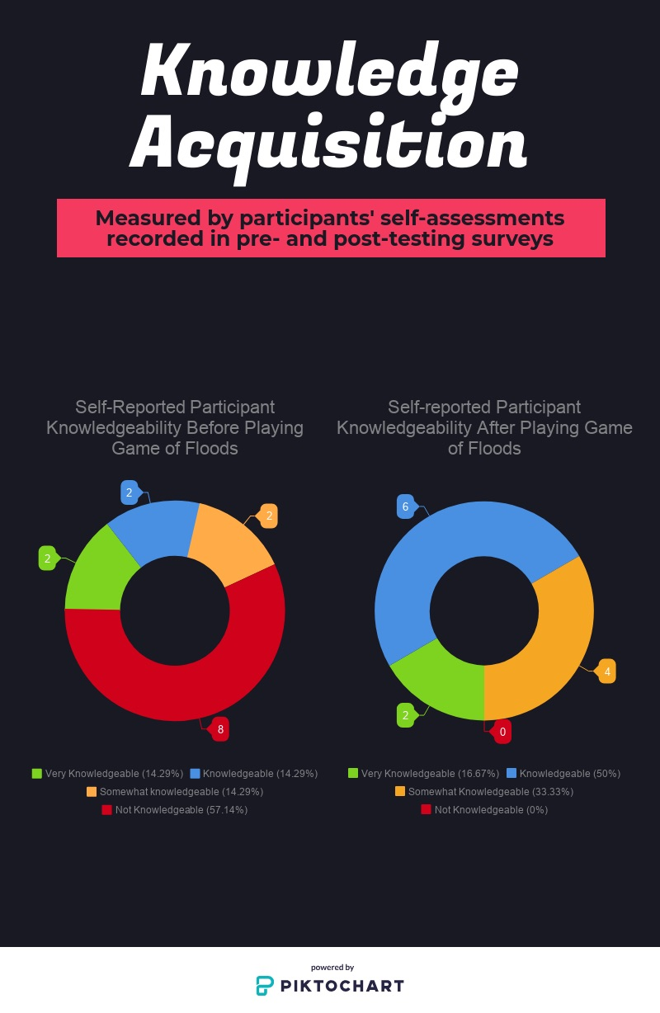

**Participant Responses**

We observed positive emotions made up a dominant share of total participant responses expressed towards the game, measured through verbal and nonverbal indicators, including laughter, curiosity, and sophisticated discussion. Negative emotions/frustration were expressed occasionally in the post-test, most commonly in the form of uncertainty regarding the game’s apparent lack of a victory condition. However, this lack of feedback or closure at the end of the game was an intentional design choice. Since Resilience Harbor is fictional and it is impossible to give clear predictions of how any combination of choices would impact the city’s ability to withstand future flooding and storms, it becomes difficult to discern whether one has “won” the game. Given that the stated purpose (as provided by FEMA administrator Mari Radford) of The Game of Floods is to inspire conversation about climate change mitigation, this open-endedness seems to serve that goal, making the concept of “winning” irrelevant.

Also notable was the absence of hopelessness exhibited by players at the game’s conclusion. While speculative, one could interpret a lack of hopelessness or despair as encouraging indicators, possibly signaling a connection between the knowledge acquired and feelings of greater empowerment within the world. By exposing players to real-world solutions and placing them in the role of community decision makers, Game of Floods increased the ability of players to evaluate environmental risk and consider methods of asset protection just as professionals do. One participant remarked during play “this really makes me appreciate my major”.

Overall, the interactions observed support the conclusion that Game of Floods succeeds in achieving its stated purposes of imparting knowledge and fostering hands-on engagement among participants. Perhaps the most telling interaction observed between participants can be told in a few sentences: “Wow, we’re doing all this for a fictional city. What are we doing for Norfolk?”

**Discussion**

Our sample student audience responded differently to different elements of the game’s design. They exhibited lapses in attentiveness during longer stretches of the powerpoint presentation, yet they were communicative and engaged during game phases which require group discussions. They expressed frustration with the non-intuitive color coding of inundation levels on the map, and some made an effort to stick to their roles, while others only engaged with the roles very briefly at the beginning. The players engaged in action through group discussion and debate, as is the primary mechanic of Game of Floods.

Student audiences respond to the game’s content with curiosity, absorbance of technical terminology, and increased insight about how real key stakeholders evaluate and respond to the impending threat of sea level rise. Multiple players expressed appreciation for this insight and desire to know what measures are being taken within their own coastal city to mitigate the damaging effects of flooding. No data was collected on whether or not players felt moved to become active within the community of Norfolk and advocate for flood measures but it is not unreasonable to think that increased literacy on the topic might lead to an increased likelihood of tangible engagement.

Limitations to the research methods we employed to test Game of Floods include the small sample size of participants and the potential of that group to be unrepresentative of college students as a whole. Because we conducted this research as part of a technical writing course, we were unable to conduct large-scale testing within the time constraints of a semester. Thus, we opted to limit the number of study participants to a maximum of 24. This allowed for a more intimate observation of how participants interact with Game of Floods and more comprehensive qualitative analysis.

Additionally, given that the invitation to participate in gameplay was circulated by technical and scientific writing students and a technical/scientific writing instructor, the population of participants may have a level of knowledge/interest in climate issues or crisis communication which is not representative of the average university student. To compensate, the wording of the pre- and post- gameplay assessments was constructed to focus specifically on players’ knowledge pertaining to the risks of coastal flooding, rather than climate issues in general. This choice allowed us to more accurately gauge each participant’s initial level of understanding regarding the topic of GoF and assess whether they learned through playing the game, even if our sample of study participants may have potentially been predisposed to having above-average knowledge/interest in the sciences.

**Implications for the Field**

By conducting usability testing on GoF, we gain an additional piece of insight into the specific aspects of tabletop simulation games which make them potentially viable tools for crisis communication and engagement. This research supports the conclusion that game participants react positively to situations that require teamwork and group discussion. These situations allow them to digest technical information and begin to incorporate it into their own understandings of a particular topic, as evidenced by the uptick in the technical vocabulary used by participants as gameplay progressed.

Questions that remain include whether games possess the rhetorical power to motivate players to carry over skills and ideas developed during gameplay into real-world actions or policy actions. Additionally, further studies should be conducted to assess the strengths of different game mediums at reaching and involving players of different ages, backgrounds, and learning styles.

References

Bogost, Ian. (2008). “The Rhetoric of Video Games." The Ecology of Games: *Connecting Youth, Games, and Learning.* Edited by Katie Salen. The John D. and Catherine T. MacArthur Foundation Series on Digital Media and Learning. 117–140. Accessed September 9, 2018 at doi: 10.1162/dmal.9780262693646.117

Froehlich, Jon. (2015). “Gamifying Green: Gamification and Environmental Sustainability”. In Walz, S. and Deterding, S. (Eds.), *The Gameful World*, MIT Press. Accessed November 24, 2018 at <https://www.cs.umd.edu/~jonf/publications/Froehlich_GamifyingGreen_EarlyDraft-22000words_GamefulWorldBook.pdf>

Gee, J. P. (2003). “What video games have to teach us about learning and literacy”. New York: Palgrave MacMillan. 14-15. Accessed November 25, 2018.

Kluver, D. B., Robertson, W. M., & Agardy, R. (2018). “Role playing a city's response to climate change: Engaging undergraduate geoscience students.” *Journal of Geoscience Education, 66*(1), 25-35. Accessed September 9, 2018 at<http://dx.doi.org.proxy.lib.odu.edu/10.1080/10899995.2018.1411734>

McGonigal, Jane. (2011). *Reality is Broken: Why Games Make Us Better and How They Can Change the World.* The Penguin Press. 1-18. Accessed November 12, 2018 at <https://hci.stanford.edu/courses/cs047n/readings/Reality_is_Broken.pdf>

Mercer, T.G., Kythreotis, A.P., Robinson, Z.P., Stolte, T., George, S.M., & Haywood, S.K., (2017). “The use of educational game design and play in higher education to influence sustainable behavior.” *International Journal of Sustainability in Higher Education, Vol. 18 Issue: 3*, pp.359-384. Accessed on September 9, 2018 at <https://doi.org/10.1108/IJSHE-03-2015-0064>

National Oceanic and Atmospheric Administration (2018). “Is Sea Level Rising?” Accessed November 13, 2018 at <https://oceanservice.noaa.gov/facts/sealevel.html>

Radford, Mari. (2018). “The Game of Floods.” Internal FEMA document from *usdn.org*: unpublished. Accessed October 1, 2018 at <https://www.usdn.org/public/page/18/Climate-Change-Preparedness#ClimateTraining>

Reckien, D., & Eisenack, K. (2013). “Climate Change Gaming on Board and Screen.” *Simulation & Gaming,* *44* (2-3), SAGE Publications. 253-271. Accessed on October 1, 2018 at doi:10.1177/1046878113480867

United Nations: Intergovernmental Panel on Climate Change. (2018). “Special Report on Global Warming of 1.5 °C (SR15)” *UN IPCC, 15,* 1-32. Accessed on November 14, 2018 at <http://report.ipcc.ch/sr15/pdf/sr15_spm_final.pdf>

Reflection

I didn’t find this assignment as difficult as the others, oddly enough. I really feel like the other assignments and all the activities we did in/out of class directly contributed to the completion of this paper. This was the first time I’ve truly experienced the genre of research reports from the writer’s perspective. With each additional assignment this semester, I feel an increasing ease adopting the tone of an academic. I had no difficulty integrating or finding sources for this assignment because both the annotated bibliography and game analysis already required this of me. I think the weakest parts of this draft are the sections where I summarize and relate current scholarship and the section where I analyze the results of our usability testing. I also think I could use more visuals within the report to showcase the data in more clearly understandable ways for readers. My conference with Prof. McKitterick helped immensely with the difficulties I had connecting theories and summarizing the current consensus on the value of game-based learning.